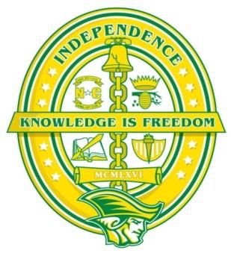
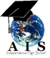
Academy of International Studies
Program of Study Academic Planner
at Independence High School
Program Requirements
Students must meet all Charlotte Mecklenburg Schools and North Carolina State Diploma requirements

Freshman Year* | Sophomore Year* | Junior Year* | Senior Year*
AIS English I | AIS English II | AIS English III  AP English | AIS English IV  AP English
AIS Freshman Seminar | AIS Sophomore Seminar | AIS Junior Seminar | AIS Senior Seminar
AIS World History | AIS Civics and Economics | AIS American History I  AIS American History II  AP US History | Elective
Math | Math | Math | Math
Science | Science | Science | Elective
World Language | World Language | World Language | World Language  (Optional; Preferred)
Elective(s) | Elective(s) | Elective(s) | Elective(s)
Community Service Hours** | Community Service Hours** | Community Service Hours** | Community Service Hours**

*AIS students will work with the AIS Director and the Independence High School Student Services department to tailor academic schedules to meet his/her needs
**Community Service Hours—Can be done during the regular school year and/or during breaks. Students are required to complete 120 hours of community service—80 serving the local community and 40 with an international focus.

AIS Certificate of Completion Path: Students are an active member of the AIS community; successfully complete classes required for graduation by North Carolina and CMS, AIS Seminar courses and at least 3 years of a World Language; complete at least 120 hours of community service (80 Local; 40 International) to earn the AIS Certificate of Completion. At graduation they’ve earned the privilege of wearing distinctive AIS stoles signifying their dedication and achievement. Certificate of Completion students will also have a seal placed on their diploma to reflect that the student earned the recognition.

AIS Certificate of Participation Path: Students enroll and participate in the AIS community, but do not complete all components of the program. At graduation, students of the Participation path will receive a certificate for their time with AIS.

